### **AI-powered Nutrition Analyzer for Fitness Enthusiasts**

### Team Leader **:** E.Santhiya

Team Member : P.Shalini, S.Sneha, M.Sridharan.

Faculty Mentor Name : Sweetline Sonia M

RUN THE APPLICATION

The pages what we create are showed in the creating html pages.pdf file.

The output of the program is shown below when we click on the submit button. The pages after entering the value are shown below

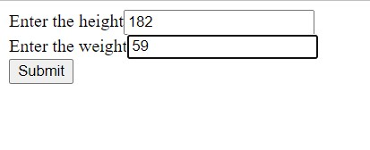

After clicking the submit button we moved to another page where we can find the BMI value for the given credentials.

